Customizing basic UI components and creating alternate programs

Contents

Overview 2

Customizing Basic UI Components 5

A. Site title and logos 5

B. FERPA 6

C. Help 7

D. Breadcrumbs 8

E. Dashboard 9

F. Module audio and Welcome modal pop-up settings 14

G. Modulette audio availability 17

Creating alternate programs 17

Setting up an alternate program in S3 18

About the modulette widget content files 18

About the module and modulette image files 18

Updating the program id mapping 19

Customizing content 20

Widget file content 20

External files 21

Narration files 21

Module and choose page images 22

# Overview

You can easily customize many aspects of the JUICE UI, including rebranding and relabeling many elements.

Without customizations, the site will display information specific to the College for America program for which JUICE was originally created.

See the section Customizing Basic UI Components for detailed instructions on how to customize JUICE.

You should review and customize the following elements:

|  |  |
| --- | --- |
| **FERPA agreement display**  Update this to show or hide the privacy agreement when students access JUICE. |  |
| **Breadcrumb**--Institution and course name  Update to reflect your own institution and program |  |
| **Help**—what help file to display.   You can choose a Generic JUICE help file (no CfA references), or provide your own. |  |
| **Dashboard**—what tabs to display  You can hide either Recently Visited or CfA Goals & Projects, or both. |  |
| **Dashboard CfA Goals and Projects** --Name, welcome text, and text labels  Customize to remove CfA references and use your own words for Goals and Projects. |  |
| **Audio icons**—show or hide the narration audio icons for all modules or mini-lessons  JUICE Module automatically play the JUICE narration. If you create new content or change the existing content, you will need to update the narration files.  You can hide the audio icons for all modules and mini-lessons in your program in the program customization settings.  You can also hide the narration for specific modules and mini-lessons. |  |
| **Welcome to JUICE modal pop-up—**show or hide the learn more link, and if you show it, what it should say. |  |

Programs that are not using the JUICE brand should ALSO customize the following:

|  |  |
| --- | --- |
| **Site title and favicon** |  |
| **Logos in the site banner and Welcome to JUICE modal pop-up** |  |
| **Breadcrumb**—Site icon and product name |  |
| **Dashboard**—JUICE modules and Student activity report tab names and welcome text that refers to JUICE |  |

# Customizing Basic UI Components

The basic UI components of the JUICE site are specified in this file, which is part of the site code. It is not stored in S3:

/components/program-value/program-value-defaults.json

Changing values in this file will you to modify the following elements of the JUICE site:

1. Site title and logos
2. FERPA
3. Help
4. Breadcrumbs
5. Dashboard
6. Module audio and welcome modal pop-up settings (includes a site logo)
7. Modulette audio settings

### **Site title and logos**

| **json parameter** | **Notes** |
| --- | --- |
| site_title | This is the title that appears on the browser tab:  Note: To replace the orange favicon, you must update the image at /public/favicon.ico |
| logo | This is the URL for the large site logo that appears in the site banner:    Enter your replacement image’s location, OR update the existing image file. Any image that you provide will be resized to 118 x 92. |
| short_logo | This is the URL for the version of the site logo that displays in the banner on the modulette pages.    Enter your replacement image’s location, OR update the existing image file. Any image that you provide will be resized to 155 x 35. |

### **FERPA**

| **json parameter** | **Notes** |
| --- | --- |
| require_ferpa | Shows or hides the JUICE privacy agreement:    Set to “True” to ensure that users see this agreement when they first access JUICE. They will need to check the checkbox to agree before they can enter JUICE.  Set to “Hide” to ensure that users do not see this agreement.  To update the FERPA document itself, update the document in S3:  **/docs/privacy_policy.html**. |

### **Help**

| **json parameter** | **Notes** |
| --- | --- |
| hide | Shows or hides the help icon.    Set to “True” to remove the help icon. |
| help_type | If you do not hide the help, you can choose which help you want to display. There are 4 options:  CfA JUICE—Default. This help references College for America and uses the JUICE product name  Generic JUICE—Help does not reference College for America, but does use the JUICE product name  Generic Unbranded—Help does not reference CfA and does not use the JUICE product name.  Custom—If this is selected, the site will use whatever help file loads from the URL specified in the path field.  The help files and their images are in the S3 in this directory:  **/docs/help**  You can replace any of them, or you can use form_hidden_help_option to specify different paths for the various help types.  Note: The value “S3_FILE_PATH” will swap in the appropriate instance of S3 as defined in the site config file. You can also use full path URLs to define the location of help documents. |
| path | If you chose a help type of “Custom,” this is the URL for the file. |

### **Breadcrumbs**

| **ison parameter** | **Notes** |
| --- | --- |
| site_parent text | Your institution name |
| site_parent program_name | Brief program name or course name    This value is set to empty for the core JUICE program. For alternate programs, this MUST have a value, or it will display an error message. |
| site text | Product name you are using instead of JUICE (if any) |
| site icon_url | Recognizable product icon.    Enter your replacement image’s location, OR update the existing image file. Any image that you provide will be resized to 14 x 14. |

### **Dashboard**

There are 4 tabs that can show on the dashboard:

coaches (Student activity report)

modules (JUICE Modules)

recents (Recently visited)

goals (CfA Goals & Projects)

Each one has a tab name, tooltip, and welcome text that can be customized:

welcome text

tooltip

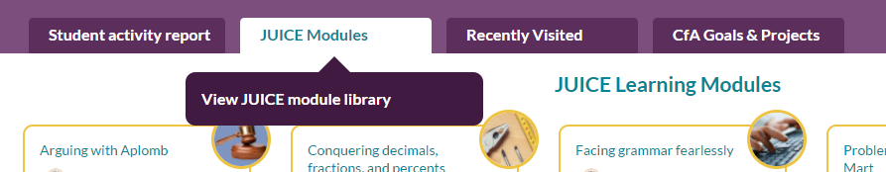

tab name

The *Recently Visited* and *CfA Goals & Projects* tabs can both be hidden:



The *CfA Goals & Projects* and *Student activity report* tabs have some additional text that can be customized.

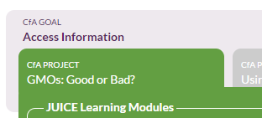

#### Coaches tab settings

The coaches tab displays the student activity report to users with a role of Coach or Educator. It requires an additional custom parameter, custom_studentId to specify what student activity to show.



| **json parameter** | **Notes** |
| --- | --- |
| label | Name that appears on the tab: |
| header_not_visited | Text that appears when a coach or educator views this tab for a student that has not yet accessed JUICE: |
| header_visited | Text that appears when a coach or educator views this tab for a student that HAS accessed JUICE: |
| tab_tooltip | Tooltip text: |

#### JUICE Modules tab settings

| **json parameter** | **Notes** |
| --- | --- |
| label | Name that appears on the tab: |
| header | Text that appears above the modules: |
| tab_tooltip | Tooltip text: |

#### Recently Visited tab settings

| **json parameter** | **Notes** |
| --- | --- |
| label | Name that appears on the tab: |
| header | Text that appears above the activity data: |
| tab_tooltip | Tooltip text: |
| hide | Allows you to hide this tab entirely.  Set to “True” to hide the tab. |

#### CfA Goals and Projects tab settings

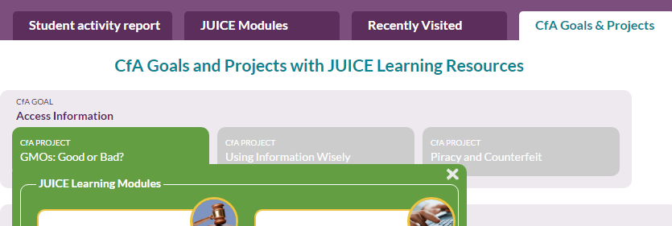

| **json parameter** | **Notes** |
| --- | --- |
| label | Name that appears on the tab: |
| header | Text that appears above the goals and projects information: |
| tab_tooltip | Tooltip text: |
| hide | Allows you to hide this tab entirely.  Set to “True” to hide the tab. |
| Group_goal_label | Title of major groupings in light purple on this page:    Use this for unit or week based groupings. |
| Group_project_label | Title of secondary groups in green on this this page:  Use this for lessons or assignments. |
| Group_modules_label | Title of JUICE item that is associated with the second level item:  Modify this if you are not using the JUICE product name. |

### **Module audio and Welcome modal pop-up settings**

| **json parameter** | **Notes** |
| --- | --- |
| hide_main_audio | Hides or shows the audio icon at the top of the module page for all modules in the program.    Set to “True” to hide this icon.  You can also show or hide icons for specific modules. If you plan to use the specific module settings, then the program level settings must be set to show. |
| hide_sub_audio | Hides or shows the audio icons within each modulette group for all of the modules in the program:    Set to “True” to hide these icons.  You can also show or hide icons for specific modules. If you plan to use the specific module settings, then the program level settings must be set to show. |
| modal logo | When you link to a specific JUICE module, a modal pop-up provides additional information about the module and about JUICE.  “modal logo” the logo that displays on the pop-up:    Enter your replacement image’s location, OR update the existing image file. Any image that you provide will be re-sized to 147 pixels wide. |
| show_learn_more_link | You can choose to show or hide the learn more link that appears on the Welcome to JUICE modal pop-up:    Set to “False” to hide the link. |
| learn_more_link_label | This is the title of the learn more link:    Update this text to remove the JUICE reference if you are not using the JUICE product name and you are not hiding the link. |
| learn_more_content | This is the text that appears when you click the link:    If you do not hide the learn more link, update this text to remove the CfA references. |

### **Modulette audio availability**

| **json parameter** | **Notes** |
| --- | --- |
| hide_main_audio | Hides or shows the audio coaching button at the top of the modulette page for all modulettes in the program:    Set to “True” to hide this button.  You can also show or hide icons for specific modulettes. If you plan to use the specific modulette settings, then the program level settings must be set to show. |
| hide_sub_audio | Hides or shows the audio buttons within the Overview steps for all modulettes in the program:    Set to “True” to hide this button.  You can also show or hide icons for specific modulettes. If you plan to use the specific modulette settings, then the program level settings must be set to show. |

# Creating alternate programs

“Core JUICE” consists of a collection of modules and mini-lessons that were created as part of a First in the World grant from the U.S. Government.

You may create alternate programs that use some or all of the core JUICE modules and mini-lessons either exactly as created, or with program-specific modifications. A program may also add its own modules and mini-lessons.

## Setting up an alternate program in S3

To set up a new program:

1. Create a new directory in the **programs** directory. The name you give this directory will be the program_id. Keep it short—it must be unique!
2. Copy the following into the new directory:
   1. programs.json from the sample program directory
   2. modules.txt from the top level S3 bucket
   3. Module directories for each of the modules you want in the new program.
3. Modify modules.txt to remove the modules you are not including in the alternate program, and to reorder as appropriate. See the document *Customizing JUICE Hom*e for more information.
4. Modify programs.json as described in the section called Customizing Basic UI Components
5. Update the Mongo DB Search tables to include search references for the new program. See the document *Using tags to improve JUICE Search* for more information.
6. Update program_id_mapping.json to include a mapping for the new program as described in the section called Updating the program id mapping

### About the modulette widget content files

The paths to the widget content files that the alternate program will use are defined in the modulette.txt files.

These point to the core JUICE files, so the alternate program will NOT use any of the content files that were copied as part of copying the module directories. If you edit the content files in core JUICE, the changes will automatically appear in the alternate program.

You can remove the content files from the alternate program to avoid confusion. See Customizing content for information about customizing and adding content to the alternate program.

### About the module and modulette image files

The JUICE logic for the module and modulette image files is to look in the program’s directory for the image file, and display that. If it’s not there, it will look in the core JUICE directory and display the image file found there.

You can remove the image files from the alternate program to avoid confusion.

## Updating the program id mapping

To access an alternate program, the LTI launch must include a “custom_program_key” value that tells JUICE what program to load. If the custom_program_key is not present or not recognized, JUICE will load the core JUICE version of the site.

A program id may have more than one custom_program_key mapped to it. For example, if all writing courses will be accessing the same alternate JUICE program, the mapping for the alternate program could include each of the course numbers.

The program id / program_key mappings are in the file **program_id_mapping.json**. Update this file as follows:

* 1. Download the program_id_mapping file from the programs directory in S3
  2. Using Brackets or some other structured editor, open a file, copy the sample entry, and update with the correct values for the new program.

S3 directory name and program id

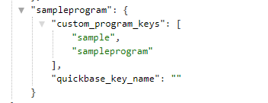

Null unless you are using Quickbase for content management

Values that must be included in the LTI launch

* The first value in the entry is the program id. This is the same as the program’s directory name in S3.
* custom_program_keys are the values that must be included in the LTI launch. For testing convenience, we recommend that you list the program’s id as one of the custom_program_keys. Then add the others that you need. You can add or update these at any time.
* Leave the quickbase_key_name blank unless you are using Quickbase for content management. If you are using Quickbase for content management, review the documentation “Creating a new program for admins” in the Working in CAMPER for admins directory for more information.
  1. Upload the new program_id_mapping json to the S3 programs bucket.

You must reload the file into the site for the new program keys to take effect:

1. Log in to the server as Alistair Admin using the test page log-in /juice/oauth_test
2. Go to this URL to reload the file with the new program entry:

<https://[yourjuiceurl]/juice/reload>

## Customizing content

### Widget file content

The URLs for the widget files used in a modulette are defined in the file **modulette.txt**. When you create a new program, your modulette.txt file still has the URLs from core JUICE. If you want the modulette content files to be different from Core JUICE, or you want to add new content files, you must update modulette.txt to point to the new files.

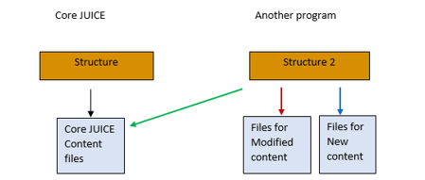

To update a content file:

* 1. Copy the file from core JUICE into your new program (if you deleted it)
  2. Use the authoring tools to make the edits you want (See *JUICE site structure and customization overview*)
  3. Download and open modulette.txt in Brackets or some other structured editor.
  4. Update the file name showing in the “files” array to add this before the file name: programs.[program directory name].

Example (program directory name is betsy2):





If you wish to create a new modulette in your alternate program, follow the instructions in the document *Customizing and creating a new modulette.*

### External files

if you want the alternate program to load different external files than the core JUICE program, to the following:

* + - 1. Add the external files to the appropriate modulette directory.
      2. Copy the widget files that point to the external file into the modulette directory (if you previously deleted them).
      3. Use the content editors to update the external file URL.
      4. Update **modulette.txt** to point to the updated instances of the widget files.

### Narration files

JUICE looks for audio files in a program’s own narrations directory and will play them if found. If none are found, JUICE will look core in the JUICE narration directory.

If you wish an alternate program to play a different version of a narration file—for example, you have updated the content of a mini-lesson step--do the following:

1. Create a directory for your program in the narrations directory, and add directories to it for the module and modulette.
2. Upload the audio file to the modulette directory, using the appropriate name.

JUICE will find this file first and play it.

For more information about working with audio files, see the documentation *Adding and customizing narration files.*

### Module and choose page images

JUICE looks for images in program’s own directory and will use them if found. If none are found, JUICE will look in the core JUICE directory. If none are found there, JUICE will display a placeholder based on the JUCIE logo.

To update images in an alternate program:

* 1. Upload the new image to the appropriate module or modulette directory in the new program.